Tele Direct

A DevCenter Project

Written by

Akash Gupta

Under the guidance of

Milind Neginhal



Contents

1. User Stories 3

1.1 Subdivision into tasks 4

2. The User Interface 5

3. Use Cases 8

4. Class Diagrams 9

# User Stories

**Story A**

As a telephone operator, I would like to view the stored contacts in the company database so that I can relay calls as requested to me.

**Story B**

As a contact manager, I want to be able to add a new contact to the telephone directory so that the new contact is accessible to others in the company.

**Story C**

As a telephone operator, I would like to be able to update the contact details of a person so that the telephone directory is updated for use.

**Story D**

As a contact manager, I want to be able to delete a contact from the telephone directory when a person has no more ties with the company.



## Subdivision into tasks

Table 1.1 The Plan

|  |  |  |
| --- | --- | --- |
| **User Story** | **Tasks** | |
| **Task Details** | **Effort Estimation** |
| Story A | * Set-up development environment * Make use case diagrams * Design the user interface * Generate class diagrams * Generate the designed UI using VC++ * Make the UI controls functional * Create a schema for the database * Implement the schema on MySQL * Write test queries for the database * Create a database wrapper class to access the database records. * Write program logic to fetch the records from the database and display it to the user * Write test classes for the application | * 4 hours * 4 hours * 4 hours * 4 hours * 8 hours * 4 hours * 4 hours * 2 hours * 2 hours * 4 hours * 4 hours * 8 hours |
| Story B | * Create a dialog object and show the form to add the contact details * Add functionality to add a photo for the contact * Write the logic to save the new details to the database | * 8 hours * 4 hours * 4 hours |
| Story C | * Show the dialog object in update mode to view/update the contact details. * Add functionality to change a photo for the contact * Write the logic to update the contact details on the database | * 4 hours * 1 hour * 4 hours |
| Story D | * Create a delete functionality for the database * Implement a delete contact feature on the Main Application dialog * Implement a delete button on the Modify record dialog | * 4 hours * 2 hours * 2 hours |

# The User Interface

The wireframes for the user interface are shown below.

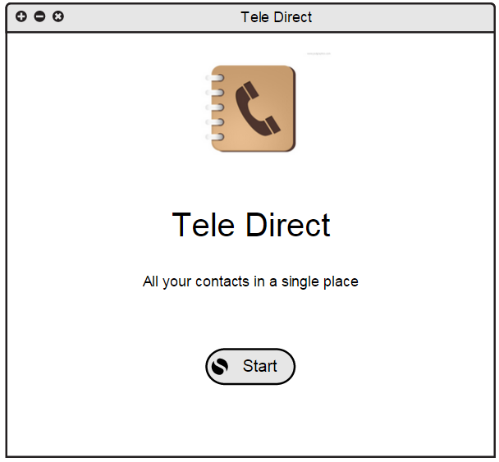

Figure 2.1 The Welcome Frame

The Figure 2.1 shows the welcome screen when the application is fired up. The user presses the start button to continue to the main application where all the stored contacts are displayed.

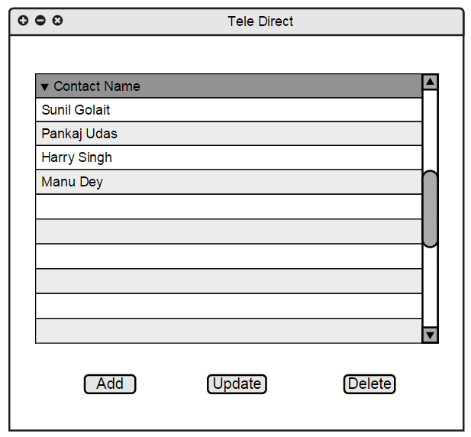

Figure 2.2 The Main Application Dialog

Figure 2.2 shows the **main application** dialog where all the contacts in the telephone directory are shown. The user is allowed to view, update, add or delete contacts. On double-clicking a record, the **Modify Record** dialog pops up where the user can update/delete the contact details.

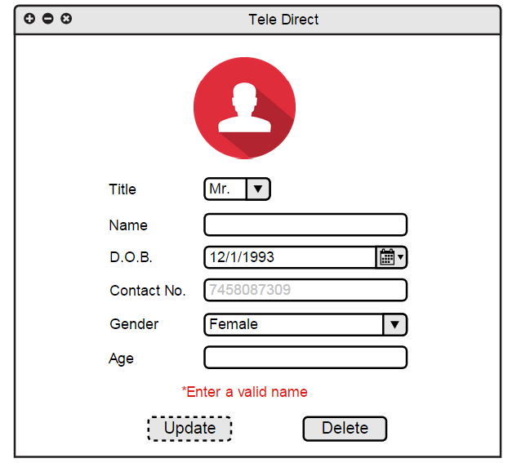

Figure 2.3 The Modify Record Dialog

In the **Modify Record** (Figure 2.3) dialog, the user can view the contact details, update the name, photo, contact number and other details as required. The user is also able to delete the particular contact after which the dialog closes and returns back to the Main Application dialog.

# Use Cases

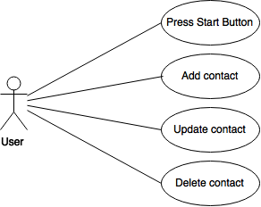

Figure 3.1 Diagram showing the user and the use cases

Figure 3.1 shows the various use cases for the user of the telephone directory application. The use case has been discussed in detail in the following Table 3.1.

Table 3.1 Use case details

|  |  |
| --- | --- |
| **Use Case** | **Details** |
| Press Start Button | The pressing of start button takes the user to Main Application dialog where the user can perform CRUD operations on the telephone directory. |
| Add Contact | The user adds a new contact and its details to the telephone directory. |
| Update Contact | The user updates the title, name, d.o.b., contact number, gender, the photo and/or any other possible combination of the fields for a particular contact. |
| Delete Contact | The user deletes a contact from the telephone directory. |

# Class Diagrams